Recommendations
Table of Contents
Mind-Map: Elevator Pitch & Recommendations to Improve Breakthrough Innovation Capabilities 2
Recommendations to Improve Breakthrough Innovation Capabilities 3
Realign strategic levers 3
Launch of an organizational wide innovation initiative 3

Mind-Map: Elevator Pitch & Recommendations to Improve Breakthrough Innovation Capabilities

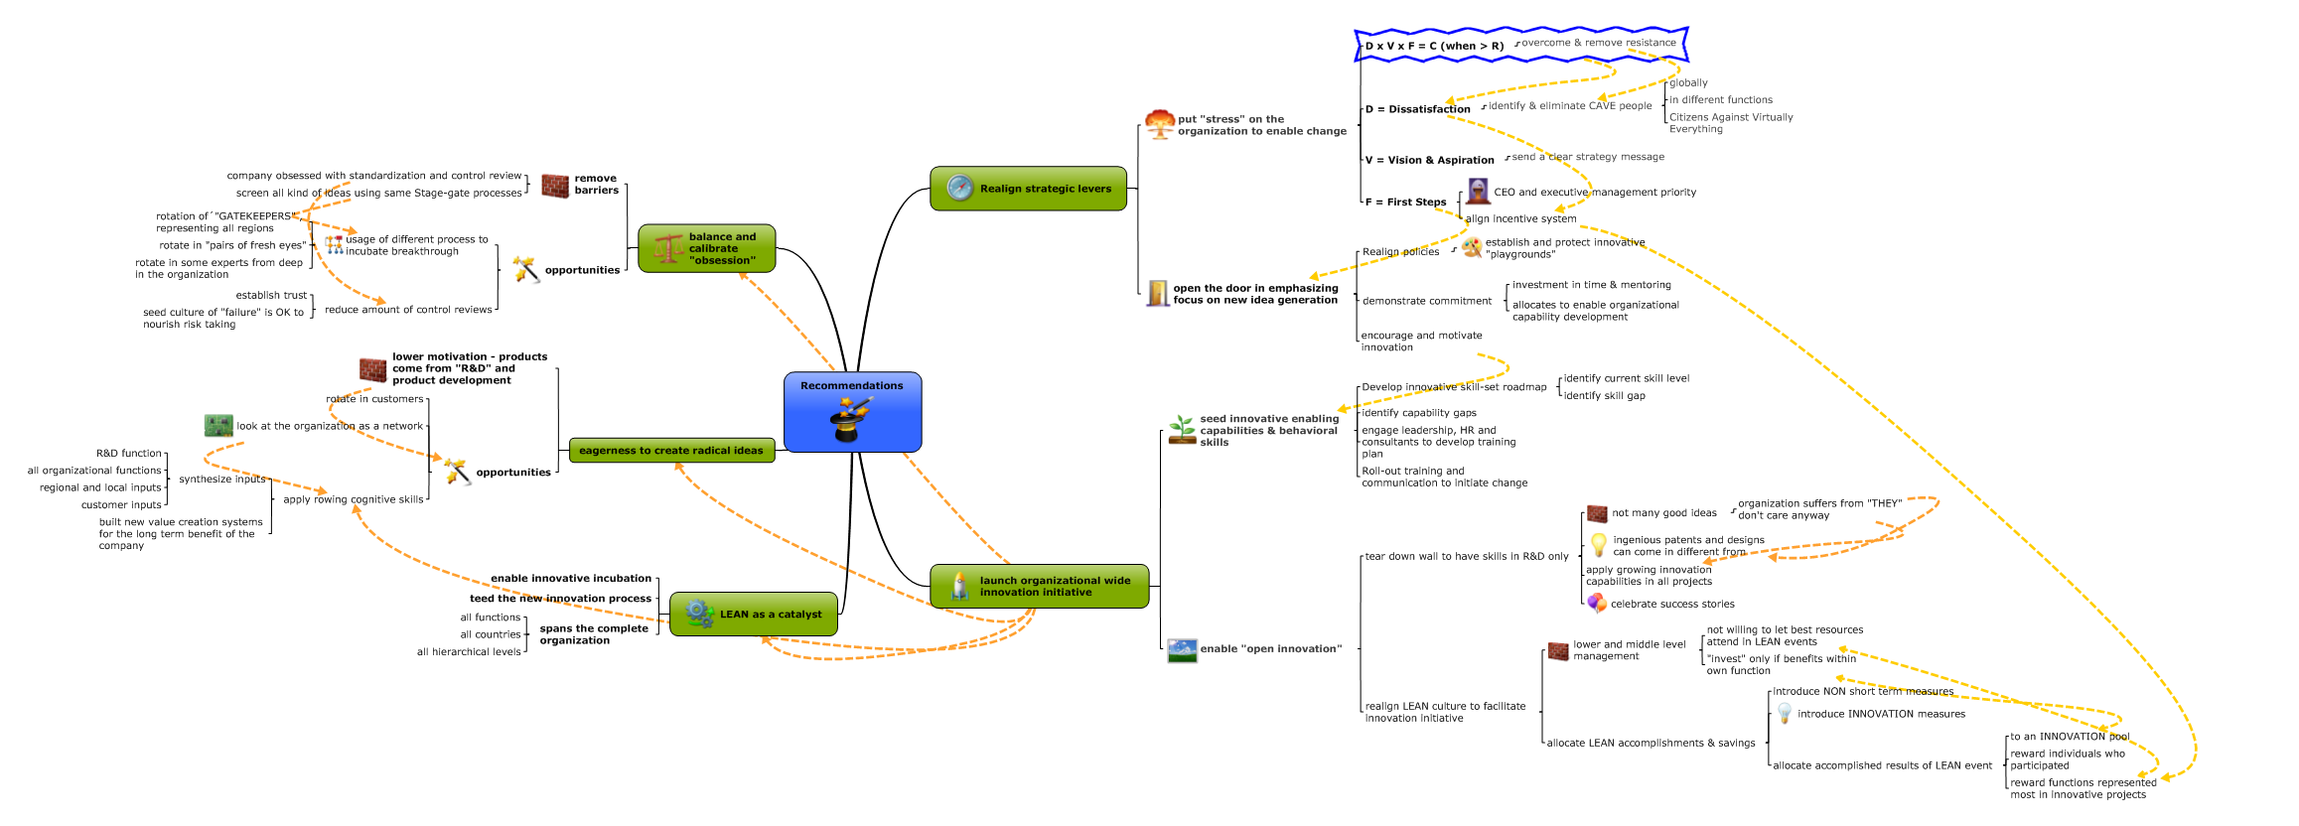

Recommendations to Improve Breakthrough Innovation Capabilities
The recommendations for my company would be to focus on two major initiatives which will built upon each other:
- Realign strategic levers
- Launch of an global organizational wide innovation initiative
Kennametal is with its DNA in the operations stage and as a mature company at a saturated market with limited growth potential, competing heavily in commodity products. Therefore, incremental and fragmental initiatives would not lead to any significant. The company needs a “crisis”, initiated from the inside-out to infuse new “Innovation-DNA” and to plant seeds to let this DNA rejuvenate and blossom. With the current structure, the deeply rooted incremental short-term focused linear thinking and isolated innovation potential, it requires a radical shift. As a result, in my previous assessment identified weaknesses would automatically dissolve. For examples on the identified weaknesses (represented by the symbol of a wall) and opportunities, see following branches on the mind-map above: “Eagerness to create radical ideas” and “Balance and calibrate "obsession".

Realign strategic levers
In order to move away from the corporate centric innovations group, it is critical to put “stress” on the global organization. We have a great opportunity to stop thinking “Innovation is done at the head-quarter. We even have a group for that”. It is important to look at our organization as a system or a human body and innovation can come from any cell.

The application of the formula D x V x F = C (if >R) is a good way to focus our activities. To facilitate change and overcome resistance we have to Create Dissatisfaction (D). We need to identify and address the issues of having C.A.V.E. (=citizens against virtually everything) people in the organization. Doing so, we need to identify and if required eliminate those pinch points in all functions and all level in all consequence. We have to offer a vision and aspiration (V) in sending a clear mission and strategic message deep into the organization and need to offer training and information on the implications to our organization and the work-environment we used to work in. And finally we have to send signals and Start with irreversible first steps (F). Therefore it is critical that the complete executive management, lead by our CEO send that message that “the train is leaving”. Another signal will be to align the incentive system along the innovation potential we want to unleash in the organization.
This initial activities and signals will open the door to enable innovation energy to blossom in emphasizing the focus on new idea generation. In that regard, we want to revisit and align our policies and procedures. It is critical to establish and protect innovative “playgrounds”. While the initial strong signal form executive involvement creates a momentum it requires continuous demonstration of that commitment in form of time dedication and active mentoring as well as allocation of financial resources to enable to required organizational capabilities to develop.

Launch of an organizational wide innovation initiative
Establishing a organization where innovation becomes part of the system’s DNA, we need to seed innovation enabling capabilities and behavioral skills cross the organization. First we want to develop an innovative skill-set roadmap in identifying the current organizational skill level and then the required skill sets and skill levels of the organization. The result can be a spider-web diagram visualizing capability gaps. It is critical to fully engage leadership and all stakeholders while HR needs to take a strategy role, leading the organization to develop training plans to close identified gaps while seeding completely missing skills. As a second step we need to roll-out the training and launch a responsive communication initiative. In a last step we then support values and systems in the organization to enable “open innovation”. We can tear down the wall of the conventional R&D center and the U.S. centric innovation team in internalizing the theme of innovation in the complete organization. This would get us away from the “They do the innovation. They do not care for our ideas anyway.” Literature has shown that great ideas and synthesizing new innovations as well as ingenious patents do not necessarily come from so-called experts. While starting that innovation journey, it is critical to celebrate success stories as we move forward.
We can use or perfectly established Lean culture and tools to feed the pipeline for Incubation, establishing a parallel innovation funneling process. This process could be established in addition to the conventional purely technology and product oriented process and would be accessible for the complete organization as a system (all levels and functions in all countries).
Under the umbrella of the innovation initiative we can realign and recalibrate our LEAN culture to make it an engine for potential innovative idea generation to feed the newly established innovation process. We need to address the unwillingness of some lower and middle management representatives to let their best resources joining cross function teams unless the time investment will benefit the function they represent. While every function has to deliver on certain LEAN savings per function and the function hosting the LEAN even gets full credits for the savings today, we want to measure and to allocate LEAN accomplishments and savings differently tomorrow. We can introduce NON short term measures and establish innovation measures. The achieved accomplishments could all to an innovation pool. The benefit allocation goes directly to the functions via the numbers of participants and time allocated to enable innovation.

